
It’s Too Loud

Sometimes in my classroom, there is too much noise. It is loud and it bothers my ears.
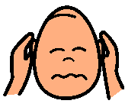
When it’s too loud, I can:

SAY: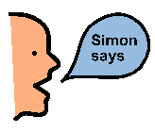 or or
That’s too
loud!
Please stop that!
I need a break.

When it’s too noisy loud, I can:

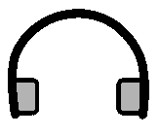Put on my headphones

OR

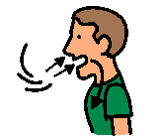Take deep breaths.

When things are loud, I can stay calm and in control.

